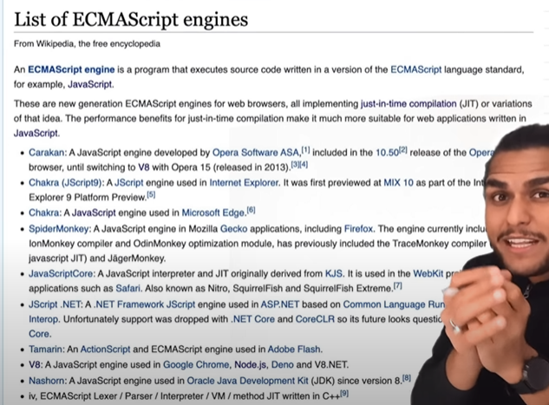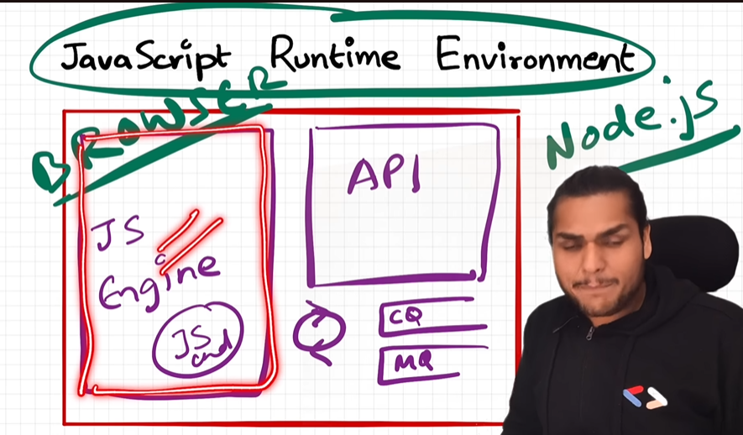 Some apis like :- console & setTmeoue are present in both node.js and browser.

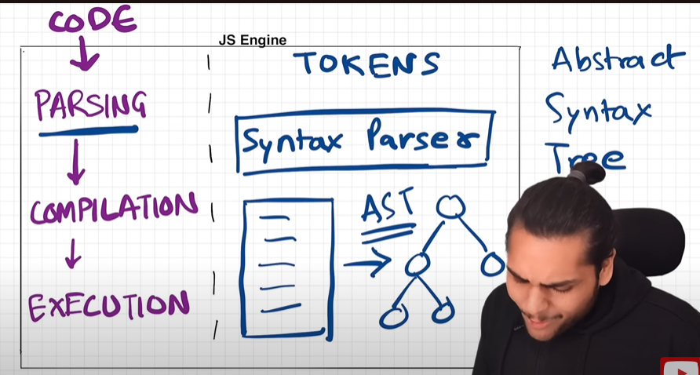



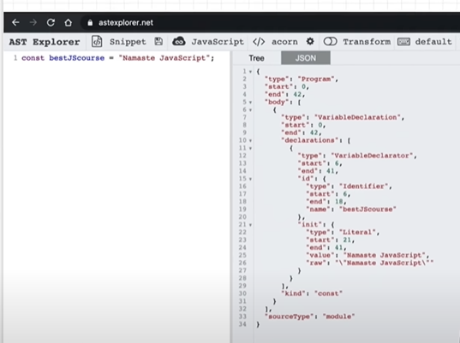

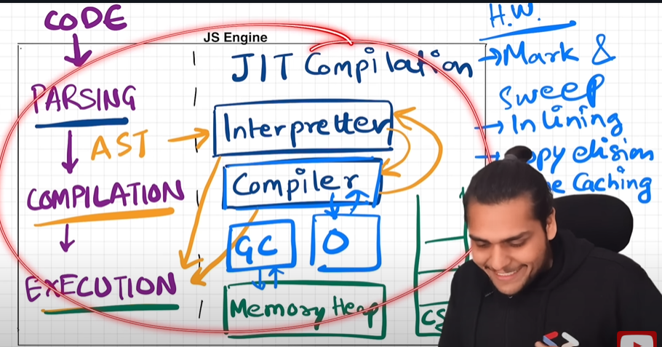

GC->Garvage collector, O-> optimization techniques.|||jit-just in time.

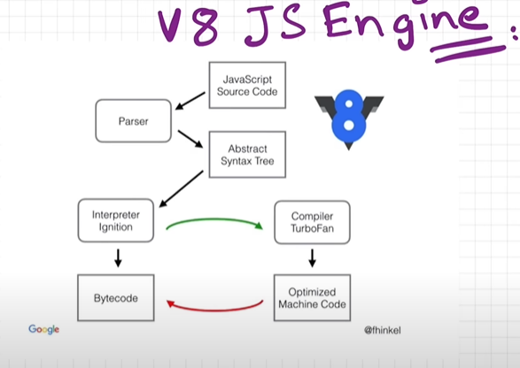

Things learned:

1. JS runtime environment contains all elements required to run JS.

2. It contains JS engine, set of API's, callback queue, microtask queue, event loop.

3. JS engine is a piece of code.

4. Process includes Parsing ---> Compilation -----> Execution.

5. Parsing breaks code into tokens and converts it into AST(Abstract Syntax Tree).

6. Modern JS engine follows JIT compilation, it interprets while it optimises code as much as it can.

7. Execution and Compilation are done together.

8. Execution has Garbage collector and other optimisation such as inlining, copy elusion, inline caching etc.